**Practical No. 4**

1. **Design a Program for creating machine that accepts**

**three consecutive one.**

1. **Accepting String**

**Code:**

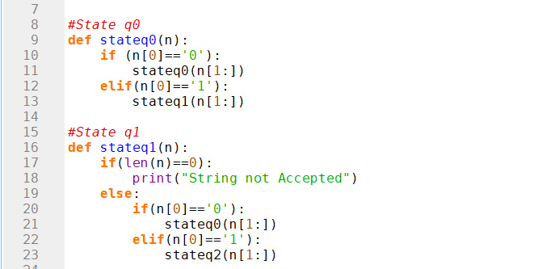

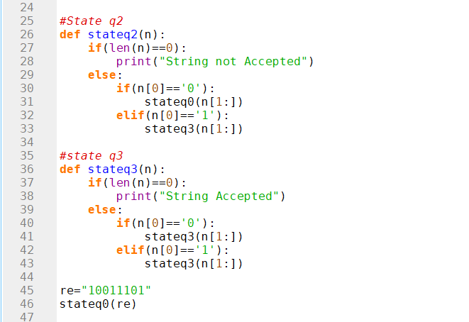

**Output:**

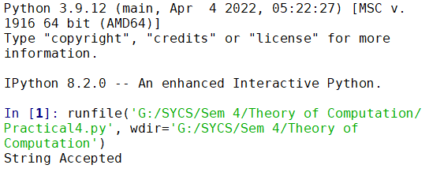

1. **Not Accepting String**

**Code:**



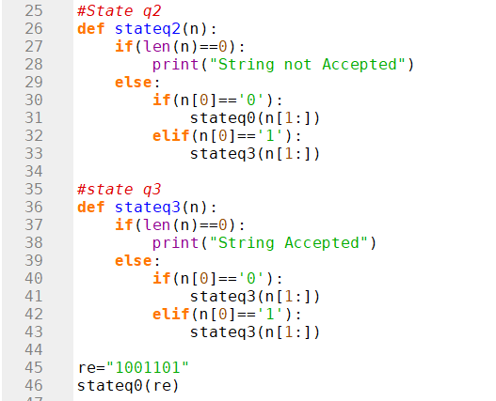

**Output:**

